Novel Steel-Fiber Reinforced Sintered Fly Ash Light Weight Aggregate Concrete for Crash Barrier Applications
Haruna Al-Amir¹, Pratik Kanungo², Anush K Chandrappa³, Dinakar Pasla⁴

¹Post Graduate Student, School of Infrastructure, IIT Bhubaneswar, Odisha – 752052, Email: 24SE06013@iitbbs.ac.in
²Research Scholar, School of Infrastructure, IIT Bhubaneswar, Odisha – 752052, Email: a23ce09018@iitbbs.ac.in
³Associate Professor, School of Infrastructure, IIT Bhubaneswar, Odisha – 752052, Email: akc@iitbbs.ac.in
⁴Professor, School of Infrastructure, IIT Bhubaneswar, Odisha – 752052, Email: pdinakar@iitbbs.ac.in
Abstract: Conventional reinforced concrete crash barriers are widely used due to their strength, durability, and low maintenance requirements. However, their high rigidity can transmit large impact forces to vehicles and occupants, thereby increasing the risk of severe injury. In addition, under severe impact loading, these barriers may fail in a brittle manner and generate high-velocity fragments, posing additional hazards. To address these limitations, this research explores the use of sintered fly ash aggregate (SFA)-based lightweight concrete reinforced with hooked-end steel fibres to improve energy absorption, ductility, crack resistance, and fragmentation control. A baseline M40 normal- weight concrete mixture and a series of lightweight fibre-reinforced mixtures with varying steel fibre contents were developed and experimentally evaluated. The investigation included fresh properties, dry density, compressive strength, splitting tensile strength, and impact resistance, assessed using drop-weight tests. Furthermore, the deformation behaviour and energy-absorption characteristics under impact loading were analysed, along with a cost and energy-efficiency assessment to identify the optimal mixture. Scaled one-third crash barrier models were fabricated using the selected lightweight fibre-reinforced mixture and compared with conventional concrete barriers under pendulum-type impact loading. The results indicate that incorporating steel fibres significantly enhances tensile strength, impact resistance, post-cracking behaviour, and energy absorption capacity. The optimised mixture exhibited improved ductility, reduced fragmentation, adequate strength, and lower density. Overall, this study demonstrates that steel fibre-reinforced lightweight concrete incorporating sintered fly ash aggregate is a promising and sustainable alternative for crash barrier applications, offering improved safety performance through reduced force transmission, enhanced energy dissipation, and controlled damage.
Keywords: Lightweight concrete, steel fibre-reinforced concrete, sintered fly ash aggregate, crash barrier, impact resistance, energy absorption, ductility, fragmentation control, sustainable material.

- INTRODUCTION
Road traffic accidents remain one of the most pressing public health challenges of the modern era. A run-off-road (ROR) accident occurs when a vehicle leaves the designated roadway and collides with a traffic barrier, utility pole, tree, or other roadside obstacle. On divided roads and motorways, head-on crashes also occur when vehicles veer across the median and strike oncoming traffic. Both types of crashes frequently result in fatalities or life-altering injuries. According to the World Health Organisation (WHO), approximately 1.3 million people die in traffic accidents every year, with millions more sustaining serious injuries. The Association for Safe International Road Travel (ASIRT, 2026) similarly reports that road traffic crashes claim roughly 1.19 million lives annually. In the United States alone, run-off-the-road collisions accounted for 62% of all fatal crashes in 2013 (Mehrara et al., 2020), and a 2010 report recorded approximately 5,419,000 police-reported crashes resulting in 32,885 fatalities and over 2.2 million injuries (NHTSA, 2012). In India, the Ministry of Road Transport and Highways (2022) reported 412,432 road accidents in 2021, claiming 153,972 lives and injuring 384,448 people, a significant proportion of which involved vehicles veering off the road or striking roadside obstacles.
To mitigate these fatalities, crash barriers are installed along the sides and medians of highways. These are roadside safety features designed to prevent vehicles from leaving the roadway, entering oncoming traffic lanes, or colliding with hazards such as trees, steep embankments, or utility poles. According to IRC:119-2015, crash barriers installed on high-speed highways help redirect errant vehicles back onto the roadway, significantly reducing accident severity (Raj et al., 2020). Research has shown that crash barriers can reduce the likelihood of fatal and severe injuries by approximately 45% to 50% (Li et al., 2018).
Crash barriers are broadly classified into three categories based on their structural behaviour: flexible barriers such as cable systems, semi-rigid barriers such as W-beam metal guardrails, and rigid barriers such as reinforced concrete barriers (IRC:119-2015). Each category presents distinct advantages and limitations. Flexible barriers offer the greatest energy absorption through deflection, resulting in lower impact severity on vehicle occupants. However, they are the most prone to failure under high-impact conditions, require substantial deflection space and frequent maintenance, and pose risks of vehicle penetration or ejection from elevated structures such as flyovers (Tambe et al., 2024). Semi-rigid barriers provide moderate deflection and reasonable energy absorption, though steel guardrails are susceptible to corrosion, often require repair or replacement after each significant impact, and still demand a clear zone to accommodate deflection (Zhang and Baral, 2018). Rigid concrete barriers, by contrast, exhibit little to no deflection and are widely preferred for their durability, low maintenance requirements, and cost-effective crashworthiness (Pan et al., 2023; Raj et al., 2020). Reinforced concrete barriers are particularly favoured in infrastructure projects owing to their structural strength, longevity, and relatively low construction costs (Mai et al., 2025). The Indian Roads Congress mandates the use of rigid concrete crash barriers on bridges and rail over bridges (ROBs) [IRC:SP:84-2014], specifies New Jersey-profile barriers under IRC:6-2016, and prescribes a minimum concrete grade of M40 for crash barrier applications under IRC:119-2015.
Despite these advantages, conventional concrete crash barriers suffer from a fundamental limitation in their excessive rigidity. Under vehicle impact, rigid concrete barriers transmit high deceleration forces directly to the vehicle and its occupants, increasing the risk of severe injury or fatality (Mohammed and Zain, 2016; Zain and Mohammed, 2015). Traffic barriers, after utility poles and trees, are the most common fixed-object cause of fatalities on highways (AASHTO, 2011). Studies from Malaysia have reported driver fatalities resulting directly from vehicle collisions with concrete median barriers (Mohammed and Zain, 2016), and in China, approximately one-third of all fatal highway incidents are attributed to such impacts (Yang et al., 2019). Under high-speed impact, concrete barriers are also known to fracture into large, high-velocity fragments that act as hazardous projectiles, posing serious risks to other road users and property (Shen et al., 2014). A documented incident in South Korea resulted in the death of a vehicle occupant struck by a fragment ejected from a concrete median barrier during a collision (Kim et al., 2019). Furthermore, conventional concrete barriers exhibit poor resistance to crack propagation under dynamic loading (Mai et al., 2025), raising further concerns about their structural integrity following repeated impacts.
Given that concrete barriers are both the most widely deployed barrier type globally and mandatory in several jurisdictions, these limitations underscore the urgent need for an advanced concrete material that can absorb and dissipate impact energy more effectively, resist cracking, and maintain structural integrity.
Several researchers have explored alternative crash barrier systems in response to these shortcomings. Yurmutas et al. (2023) investigated a renewable hybrid barrier combining wood, steel, and sand, which was validated through pendulum impact testing and LS-DYNA simulations. While the system demonstrated improved energy absorption and reduced impact severity, wood's susceptibility to moisture-induced deterioration, biological degradation, and variable mechanical strength poses significant durability and reliability challenges in highway environments. Raj et al. (2020) studied fibre-reinforced rubcrete, a concrete in which fine aggregate is partially replaced with crumb rubber, and found that steel fibre-reinforced rubcrete achieved up to three times the impact energy absorption of conventional concrete. However, the reduction in compressive strength caused by crumb rubber inclusion, along with the need for rubber pretreatment and the added processing complexity, limits its large-scale viability. Xue et al. (2025) examined ultra-high-performance concrete semi-assembled barriers and demonstrated compliance with SB-level safety requirements. Nevertheless, UHPC's high stiffness and limited ductility result in significant energy transfer to the vehicle during impact, while its high material cost and fabrication complexity restrict widespread adoption. Yang et al. (2019) proposed a movable segmented concrete median barrier connected by steel pins, which improved impact duration and reduced vehicle deceleration by increasing segment movement and friction. While promising, concerns remain about the installation complexity, alignment precision, long-term durability of steel pin connections, and overall maintenance demands.
It is evident that existing crash barrier systems, whether conventional or alternative, still face inherent trade-offs between strength, energy absorption, crack resistance, cost, and durability. A material that simultaneously addresses these competing demands is yet to be established. Lightweight concrete offers a promising avenue in this context. While normal-weight concrete typically has a density of approximately 2,400 kg/m³, lightweight concrete achieves a density between 1,400 and 2,000 kg/m³ by substituting conventional coarse aggregates with lightweight aggregates (Elango et al., 2021). Among the synthetic lightweight aggregates suitable for structural applications, including expanded shale, clay, slag, and sintered fly ash, sintered fly ash aggregate is considered the most appropriate for structural-grade concrete (Nadesan and Dinakar, 2017). SFA is produced from fly ash, a by-product of coal-fired thermal power plants, through a high-temperature sintering process. India alone generates approximately 200 million tonnes of fly ash annually, of which around 33% remains unutilised (Sahoo et al., 2020), with its disposal requiring over 3,800 hectares of land and more than 1,000 million cubic metres of water annually (Singh et al., 2023). Utilising SFA in structural concrete, therefore, represents both environmental and economic opportunity.
From a structural performance standpoint, lightweight concrete offers several properties that are particularly advantageous for crash barrier applications. Its lower elastic and dynamic moduli compared to normal-weight concrete (Somani et al., 2025; Tian et al., 2015), combined with greater deformability (Elango et al., 2021), result in reduced stiffness and enhanced energy dissipation through deformation during impact, which directly translates to lower deceleration forces on vehicle occupants. The inherent porosity of SFA further contributes to energy dissipation through aggregate crushing and deformation under impact (Chen et al., 2010), while also reducing the ejection velocity of concrete fragments. Lightweight concrete also exhibits a higher internal damping ratio than normal-weight concrete (Li et al., 2021; Tian et al., 2015), which further enhances its capacity to dissipate dynamic energy. Additionally, SFA-based lightweight concrete demonstrates lower permeability, reduced chloride penetration, and superior corrosion resistance compared to conventional concrete (Singh et al., 2023), making it well-suited for use in aggressive environments such as coastal or bridge structures. The reduced self-weight of lightweight concrete crash barriers also lowers dead loads on bridge decks, leading to more economical structural design and reduced transportation and installation costs.
The principal limitation of SFA-based lightweight concrete is a reduction in compressive strength, which can be effectively addressed through optimised mix design (Nadesan and Dinakar, 2017). The inherent brittleness, low tensile strength, and poor fracture toughness of lightweight concrete can be overcome through the addition of steel fibres. Wang and Wang (2013) demonstrated that steel fibre reinforcement significantly enhances the ductility, toughness, tensile and flexural strength, and impact resistance of lightweight concrete through the mechanism of fibre pullout, debonding, and bridging. Among various fibre geometries, hooked-end steel fibres have been shown to provide optimum bond performance, with pull-out loads more than twice those of straight fibres (Ahmed and Dutta, 2025).
Despite these promising characteristics, no study to date has specifically investigated the feasibility of hooked-end steel fibre-reinforced sintered fly ash lightweight concrete as a material for crash barrier applications. This gap in the literature represents a significant opportunity, given that such a material could simultaneously offer impact resistance, energy absorption, crack resistance, sustainability, durability, and cost-effectiveness, all of which are critical requirements for modern highway safety infrastructure.
The primary objective of this study is to develop and evaluate lightweight fibre-reinforced concrete mixtures incorporating hooked-end steel fibres, Ordinary Portland Cement, Ground Granulated Blast Furnace Slag (GGBS), and sintered fly ash aggregates for potential application in highway crash barriers. The study aims to assess both the material-level and structural-level performance of these mixtures through a combination of laboratory testing and scaled model experiments. The scope of the work includes:
- To develop a cost-effective structural lightweight aggregate concrete incorporating GGBS, sintered fly ash aggregate, and hooked-end steel fibres.
- To investigate the fresh properties, mechanical properties, and impact resistance of SFA-based steel fibre-reinforced lightweight concrete at varying fibre dosages, and to understand the influence of steel fibre content on workability, density, mechanical strength, and impact energy absorption.
- To conduct a cost-benefit analysis and evaluate deformation behaviour under impact for all mixtures, identify the optimum mix based on energy efficiency and deformation response, and compare its performance against a baseline M40 normal-weight concrete mix.
- To test a one-third scale crash barrier model fabricated using the optimum steel fibre-reinforced lightweight concrete mix and the M40 baseline mix under impact loading.

- EXPERIMENTAL PROGRAM
  - Materials
    - Binders
Ordinary Portland cement (OPC) of 53 grade conforming to the requirements of IS 12269 (2013) was used as the binder. Ground granulated blast-furnace slag (GGBS) was used as a supplementary cementitious material (SCM), with 20% replacement of OPC. The chemical composition of binders is provided in Table 1, and Table 2 shows the physical characteristics of the binder

Table 1: XRF analysis of Cement and GGBS
Oxide | Dry weight (%)
 | Cement | GGBS
Fe₂O₃ | 3.23 | 1.5
Al₂O₃ | 5.15 | 19.98
SiO₂ | 21.29 | 31.36
CaO | 64.04 | 32.4
Na₂O | 0.08 | 0.23
K₂O | 0.5 | 0.96
MgO | 0.95 | 9.54
SO₃ | 2.10 | -
Other oxides |  | 1.02

Table 2: Physical characteristics of Cement and GGBS
Properties | Unit | Cement | GGBS
Bulk density | kg/m³ | 1400 | 1205
Colour | - | Grey | Off white
Moisture | % | <0.1 | <0.1
Specific gravity | - | 3.15 | 2.9
Specific surface area | m²/kg | 324 | 430

    - Aggregates
Natural sand conforming to Zone II as per IS 383:1970, with a fineness modulus of 2.8, was used in this study. The sintered fly ash aggregate (SFA) employed in the lightweight concrete mixtures was commercially procured from the manufacturer. SFA had a nominal size of 12.5 mm, in accordance with IS 9142 (Part 2):2018. Figure 1 shows the grain size distributions of crushed stone, natural aggregate, and SFA. Figure 2 shows the physical appearance of aggregates, and Table 3 shows the physical properties of aggregates.

Figure 1: Gradation Curve of Crushed Stone

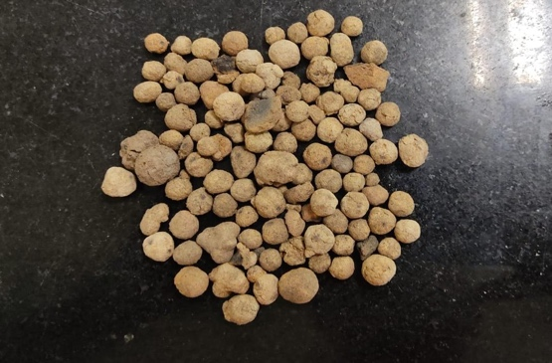  (a) | 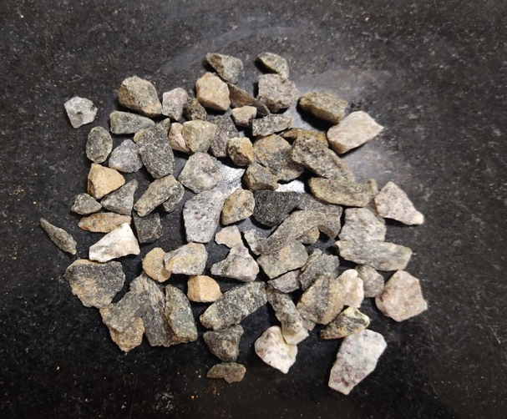  (b)
Figure 2. Physical appearance of aggregates
- SFA; (b) Crushed natural stone aggregate

Table 3: Physical properties of Aggregates
Properties | Fine Aggregate | SFA | Crushed stone | Specification
Aggregate Impact value (%) | - | 36 | 23.40 | IS 2386 (Part IV ): 1963
Aggregate Crushing Strength | - | 22.36 | 30 | IS 2386 (Part IV ): 1963
Aggregate Abrasion value | - | 33.54 | 16 | IS 2386 (Part IV ): 1963
Water Absorption (24h) % | 0.33 | 18 | 1.38 | IS 2386 (Part III ): 1963
Dry loose Bulk Density (kg/m³) | 1352 | 785 | - | IS 2386 (Part III ): 1963
Oven-Dry Bulk Density (kg/m³) | - | 816 | - | IS 2386 (Part III ): 1963
Specific Gravity | 2.460 | 1.43 | 2.730 | IS 2386 (Part III ): 1963

    - Water
Locally sourced potable water was used to prepare both lightweight (LWC) and normal-weight (NWC) concrete mixtures. In LWC, incorporating fibres along with the high water absorption capacity of sintered fly ash aggregates (SFA) tends to produce a harsh and less workable mix. To improve workability, PCE-based high-range water-reducing admixture was added to both concrete types. Furthermore, additional water equivalent to 18% of the total aggregate weight was added to the lightweight concrete mixture to compensate for the high water absorption of the sintered fly ash aggregates.

    - Hooked End Steel Fiber
Hooked-end steel fibres were incorporated to improve the mechanical and dynamic performance of the lightweight concrete mixtures. Previous research has shown that both corrugated and hooked-end steel fibres exhibit better bonding characteristics compared to straight fibres (Ahmed and Dutta, 2025). Based on this, hooked-end steel fibres (SF) were selected for the present study. The properties of SF provided by the manufacturer are shown in Table 4.
Table 4: Properties of Steel Fibres
Property | Value
Type | Hooked-end steel fiber
length | 30 mm
Diameter | 0.5 mm
Aspect Ratio (l/d) | 60
Tensile Strength | 1100MPa
Modulus of Elasticity | 200 GPa
Density | 7850 kg/m³
Physical appearance | 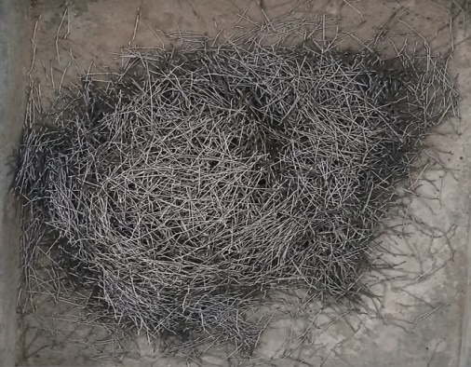

  - Concrete Mix Design

Lightweight concrete was designed in accordance with the ACI 211.2-98 guidelines. The guideline does not specify any particular lightweight aggregate for producing lightweight concrete. Therefore, an initial trial mix was prepared using sintered fly ash aggregates with a target compressive strength of 41.4 MPa (6000 psi). The 28-day compressive strength and hardened density of the trial mix were evaluated, and the results are presented in Table 5. After confirming that the trial mix met the required strength and density criteria for lightweight concrete, the final mix design was developed by replacing 20% of cement with ground granulated blast-furnace slag (GGBS). Steel fibres were then incorporated into the lightweight concrete mixtures at dosage levels ranging from 0% to 1.5% of the total volume of the concrete.
Due to the high water absorption capacity of sintered fly ash aggregates, additional water equivalent to 18% of the total weight of the aggregates would normally be required as compensation. However, since this 18% value corresponds to the 24-hour water absorption and the mixing and casting process was completed in approximately 30 minutes, the additional water was not added directly. Instead, a high-range water-reducing superplasticiser was used to achieve the desired slump and maintain workability. The lightweight concrete mixtures were designated LWC00 (0% fibre), LWC05 (0.5% fibre), LWC10 (1.0% fibre), and LWC15 (1.5% fibre). The fibre dosage was limited to 1.5% because higher fibre contents significantly reduce workability and may lead to balling effects. This limitation is consistent with the findings of Wang and Wang (2013), who reported that the optimum fibre dosage should not exceed 1.5% of the total concrete volume.
For comparison, the NWC mixture using conventional aggregates was designed as the control mix in accordance with IS 10262:2019. The final mix proportions are summarised in Table 6.
Table 5: Trial Mix of LWC
Mix ID | Cement, kg/m³ | Water,  kg/m³ | Fine aggregate,  kg/m³ | Sintered flash aggregate, kg/m³ | Superplasticizer, kg/m³ | Extra water, kg/m³ | Achieved density,  kg/m³ | Slump,  mm
LWC | 528 | 195.16 | 466.46 | 596.31 | 2.79 | 84 | 1932 | 140

Table 6: Final Mix Proportions
Mix ID | Cement, kg/m³ | GGBS,  kg/m³ | Water, kg/m³ | Fine Agg, kg/m³ | Coarse Agg.  kg/m³ | Sintered Flash Agg.  kg/m³ | Steel Fiber,  kg/m³ | Superplasticizer,  kg/m³) | Extra water, kg/m³
NWC | 338.8 | 87.4 | 173.63 | 795.62 | 948.8 | 0 | 0 | 1.90 | 0
LWC00 | 422.4 | 105.6 | 195.16 | 466.46 | 0 | 596.31 | 0 | 2.79 | 107.34
LWC05 | 422.4 | 105.6 | 195.16 | 466.46 | 0 | 596.31 | 39.25 | 2.79 | 107.34
LWC10 | 422.4 | 105.6 | 195.16 | 466.46 | 0 | 596.31 | 78.50 | 2.79 | 107.34
LWC15 | 422.4 | 105.6 | 195.16 | 466.46 | 0 | 596.31 | 117.8 | 2.79 | 107.34

  - Casting and Curing

The mixing process for LWC began with the dry mixing of sand and SFA aggregates in a mixer for approximately 3–4 minutes. Due to the high water absorption capacity of SFA, about 50% of the total mixing water was initially added, and mixing was continued for approximately 7 minutes to allow adequate water absorption by the aggregates.
Subsequently, cement and GGBS were added, and the mixture was blended for an additional 2–3 minutes. Thereafter, the remaining 50% of mixing water, along with the required dosage of superplasticiser, was introduced, and mixing was continued for a further 3–4 minutes. SF was then gradually incorporated into the mix to ensure uniform dispersion and to prevent fibre balling and agglomeration.
For the baseline NWC, cement, GGBS, sand, and coarse aggregates were first dry-mixed for approximately 3 minutes. This was followed by the addition of 50% of the mixing water, and mixing was continued for 3–4 minutes. Finally, the remaining 50% of water, along with the required amount of superplasticiser, was added, and the mixture was further mixed for an additional 3–4 minutes.
The workability of each mixture was assessed immediately after mixing using a slump test. The concrete was then placed into moulds to prepare the test specimens. To ensure proper compaction and to minimise entrapped air voids, the moulds were vibrated using a vibration table for approximately 2 minutes.
For each mix designation, three cube specimens (150 × 150 × 150 mm), three cylindrical specimens (150 mm diameter × 300 mm height), and four beam specimens (100 × 100 × 500 mm) were cast for compressive strength, split tensile strength, and impact testing, respectively. In addition to the above specimens, a one-third-scaled model of the New Jersey crash barrier was also fabricated one each for the NWC and LWC15 mixtures.
After 24 hours, all specimens were demoulded and subsequently cured in water until the specified testing age. Figure 3 illustrates the complete sequence of the mixing, casting, and curing processes.

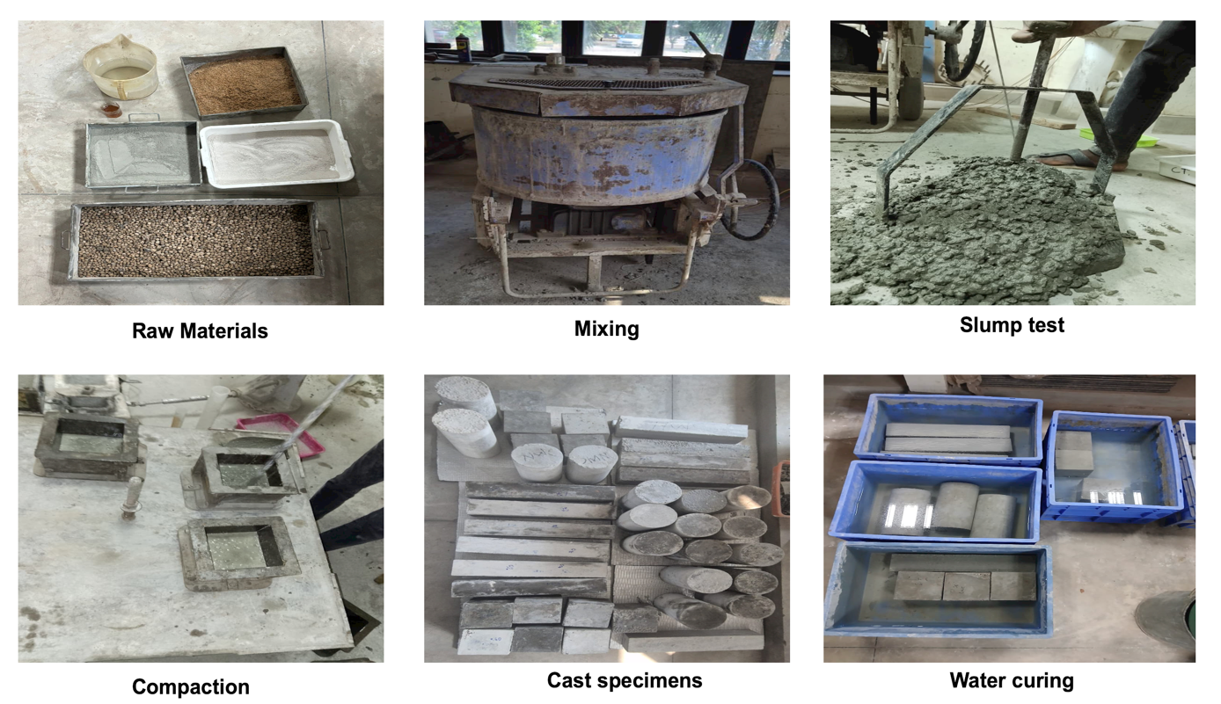

Figure 3. Casting and Curing of NWC and LWC Mixtures

- TESTING METHODS
  - Density and Mechanical Properties
The dry density of all concrete mixtures was measured in accordance with IS 1199 (BIS 1959a) to assess the influence of mix composition on density variation. The mechanical characterisation of the concrete specimens included compressive and split tensile strengths, both evaluated after 28 days of standard curing. Testing was performed in conformity with IS 516 (BIS 1959b) and IS 5816 (BIS 1999), respectively, using a servo-controlled compression testing machine (CTM) with a rated capacity of 3000 kN. All specimens were subjected to a uniform loading rate of 5.2 kN/s during testing.

  - Impact Studies on concrete prisms
The drop-weight impact test recommended in ACI 544-2R is a widely adopted method for evaluating the energy-absorption capacity of concrete. Although this test was originally developed for disc-shaped specimens, numerous researchers have extended its application to beam specimens (Raj et al., 2020; Abid et al., 2020; Mohammadi et al., 2009; Saxena et al., 2018).
In the present study, the impact resistance of concrete was evaluated using prismatic beam specimens measuring 100 × 100 × 500 mm, tested over a simply supported span of 400 mm, as shown in Figure 4.
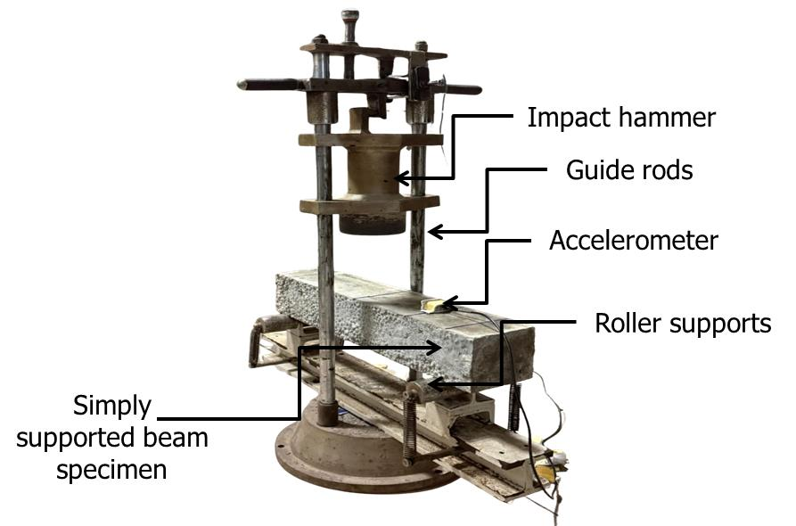
Figure 4. Experimental Setup for Impact Test on Beams
Repeated impact loading was applied by releasing a 13.5 kg drop hammer from a fixed height of 100 mm. The number of impacts required to initiate the first visible crack and the total number of impacts sustained until complete failure were recorded as N₁ and N₂, respectively. The impact energy corresponding to crack initiation and ultimate failure was subsequently calculated using Equations 1 and 2, respectively.
$E_{1}= N_{1}*m*g*h$ (1)

$E_{2}= N_{2}*m*g*h$ (2)

Where,
m = mass of impact hammer, kg; g = acceleration due to gravity, m²/s; h = height of fall, m

An accelerometer was attached 75 mm from one of the supports during the drop-weight impact test. The accelerometer recorded the acceleration of all beams at the time of the first impact. The raw acceleration data recorded during the impact test were imported into MATLAB from a CSV file for further analysis. Since the accelerometer measured acceleration in units of g, the recorded values were converted to m/s² by multiplying them with the standard gravitational acceleration (9.80665 m/s²). The sampling frequency was then determined from the average time interval between consecutive measurements using Fs=1/Δt, where Δt is the mean sampling interval. For example, if the average time interval between successive acceleration samples is 0.001 s, the corresponding sampling frequency is 1000 Hz, indicating that the data acquisition system recorded 1000 samples per second. The calculated sampling frequency was subsequently used in the design of the digital filter and other signal-processing operations to ensure accurate analysis of the impact response.
A first-order least squares polynomial was fitted to and subtracted from the raw signal to remove linear baseline drift. The corrected signal was then passed through a 4th-order zero-phase Butterworth high-pass filter at a cutoff frequency of 3 Hz to eliminate residual low-frequency content while preserving the impact dynamics. Velocity was subsequently obtained by numerically integrating the filtered acceleration using the trapezoidal rule, followed by a linear drift correction. A second trapezoidal integration was applied to yield displacement, again with linear drift removal, and the result was converted to millimetres. The peak absolute displacement was extracted as the primary output.

  - Economic Analysis of LWC
A cost-efficiency analysis was conducted for each mixture to determine the most economical mixture under impact load. A lower absolute cost may not necessarily indicate the most economical mixture, as this term does not include engineering significance. In this regard, the material cost per cubic meter and the energy absorbed at failure for each mix were used to evaluate the cost per unit of energy absorption, providing a measure of energy efficiency. Table 7 shows the unit cost of different materials, which were used for economic analysis.
Table 7. Unit Cost of Different Constituent Materials
Material | Cost (Rs/kg)
Cement | 6
Sintered Fly ash aggregate | 0.8
Coarse Aggregate | 1
Fine Aggregate | 2
GGBS | 3.5
Superplasticizer | 35
Steel Fiber | 100

Based on this parameter, mixtures with a lower cost per energy were considered eco-engineered. In addition to cost efficiency, the beam's displacement response was also considered, based on the work-energy principle: for a given impact energy, a higher displacement results in a lower momentum transfer for vehicle occupants. . Therefore, concrete mixtures with higher displacement capacity are more effective at dissipating impact energy and minimising force transmission as shown in Equations 3 and 4.

$\frac{1}{2}*m*v^{2}= \int{f(x)}dx$ (3)

$F_{avg}= \frac{1}{2}*\frac{mv^{2}}{d}$ (4)

  - Impact test on the Scaled barrier
To validate the laboratory results under realistic impact conditions, a one-third-scale model of a New Jersey-type crash barrier was cast using both the selected LWC and NWC M40. Figure 5 presents the full-scale dimensions of the crash barrier alongside its corresponding one-third-scale model, providing a clear reference for the size comparison. The dimensions for the reduced-scale crash barrier specimens were determined using dimensional similarity principles based on the Buckingham π theorem. To maintain geometric similarity between the prototype and laboratory models, all barrier dimensions were scaled down by a factor of 1:3.
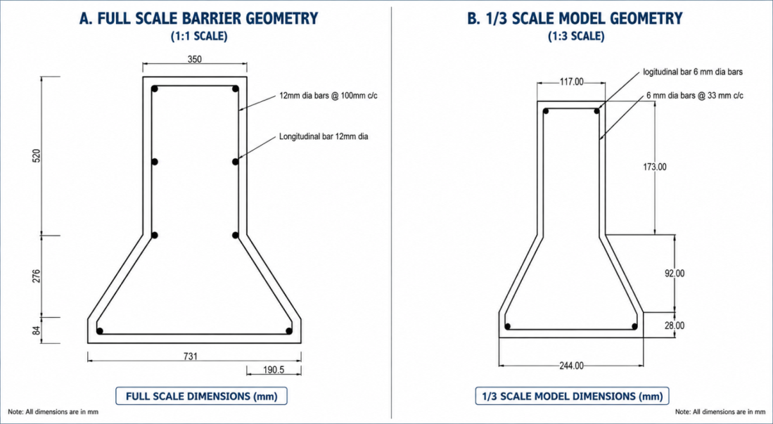
Figure 5. Cross-sectional geometry and reinforcement arrangement of the full-scale barrier specimen and the scaled-down (1:3) model used in this study

Indian Roads Congress (IRC:6-2016) prescribes vehicular collision loading for the design and evaluation of crash barriers. However, using actual vehicles is not economically feasible at the laboratory scale. To address this, a pendulum-type impact test setup was developed to evaluate the impact performance of the scaled barrier specimens. The schematic of the overall testing arrangement is illustrated in Figure 6, while the rear and front faces of the test setup are shown in Figure 7. For the impact test, a 40 kg steel impactor was suspended from a 1650 mm chain fixed to a rigid support. This setup ensured that the distance from the pivot point to the impact location at the mid-height of the barrier remained constant. The pendulum impactor was raised to an angle of approximately 38°, corresponding to a vertical rise of 0.35 m, and then released to strike the barrier specimen. The specimen itself was restrained using a simple rear support system.
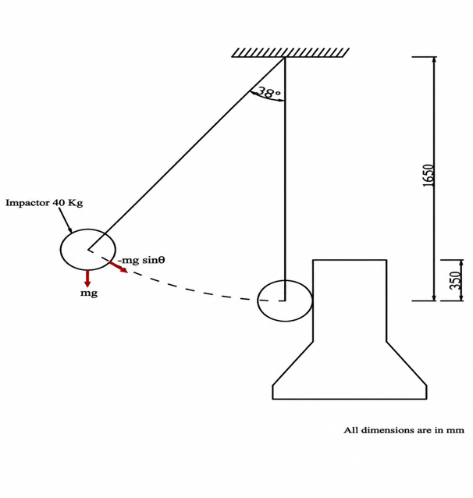
Figure 6. Schematic of Impact Test Setup of 1:3 Scaled model of Crash Barrier

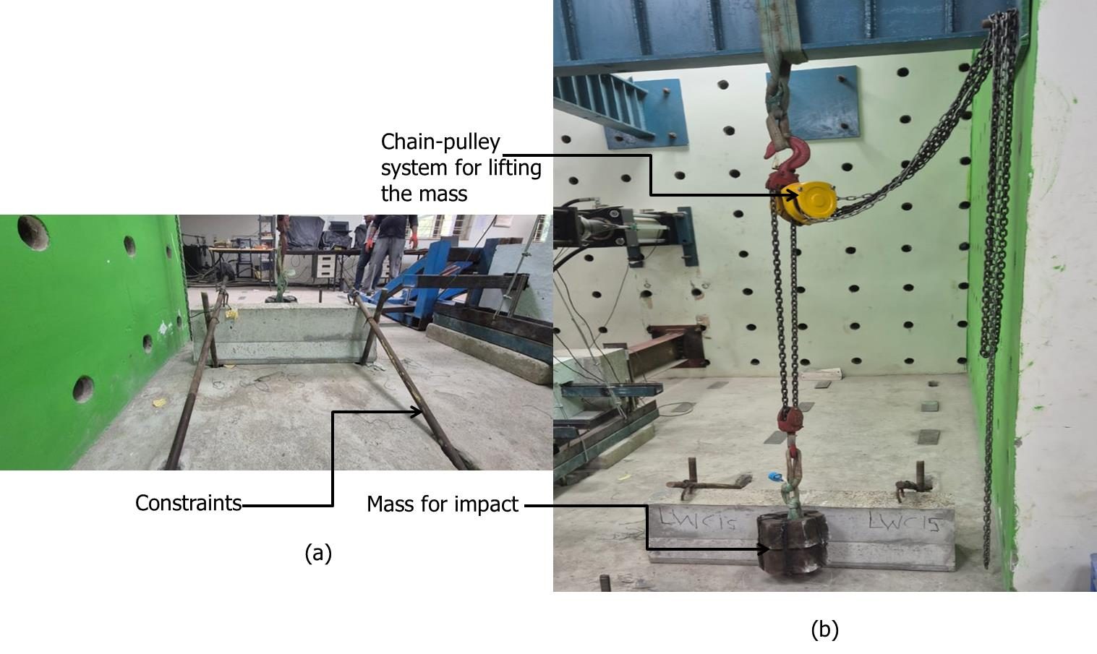
Figure 7. Test Setup for Impact Test on 1:3 Scaled New Jersey Type Crash Barrier
- Rear view; (b) Front view

The motion of the pendulum impactor is governed by the tangential component of gravitational force acting along the curved path of motion. The total gravitational force acting on the impactor is:

$F=mg$ (5)
However, only the tangential component contributes to the swinging motion of the pendulum. The tangential force acting along the arc is shown in Equation 6:
$F_{t}=mg*sin⁡()$ (6)
where θ is the angular displacement of the pendulum from the vertical. Substituting the values in Equation 6, results in a tangential force of 241.6 N per impact.
$F_{t}=40*9.81*s\operatorname{in}\left(38\right)=241.6 N$ (7)
This tangential force accelerates the impactor along the pendulum's path, converting potential energy into kinetic energy. The working principle of the pendulum impact system is based on the conservation of mechanical energy. When the pendulum impactor is raised to a certain height (h), the system possesses gravitational potential energy, as shown in Equation 8.
$E_{p}=mgh$ (8)
Where m is the mass of the impactor (kg), g is the acceleration due to gravity (m/s2), and h is the vertical rise height (m).
As the pendulum swings downward, the potential energy is progressively converted into kinetic energy. Just before impact, the energy becomes entirely kinetic. Neglecting air resistance and frictional losses:
$E_{p}= E_{k}$ (9)
$mgh= \frac{1}{2}*m*v^{2}$ * (10)
Hence, the impact velocity of the pendulum immediately before collision can be determined as:
$v= \sqrt{2gh}$ (11)
Substituting the experimental parameters:
$v= \sqrt{2*9.81*0.35}=2.62m/s$ (12)
Thus, the kinetic energy at the moment of impact is equal to the initial potential energy of the pendulum impactor. For the present study, the energy imparted per blow is calculated as:
$E=mgh=40*9.81*0.35=137.3 N-m$ (13)
Since the release height was maintained constant throughout all tests, the impact velocity and kinetic energy imparted during each blow remained constant. Repeated impact blows were applied at the selected location until the occurrence of the first visible crack and ultimate failure. The number of blows corresponding to crack initiation (N1) and ultimate failure (N2) was recorded. The total impact energy absorbed by the barrier at failure was determined by multiplying the energy per blow by the corresponding number of blows required to reach failure.
An accelerometer was mounted on the rear face of the barrier specimen, 200 mm from the left edge, to record the acceleration response during impact. The recorded acceleration signals were subsequently processed and double-integrated to obtain the velocity and displacement responses under impact loading using the same procedure described in Section 3.2.

- RESULTS AND DISCUSSION
  - Slump and Wet Density
Slump and wet density are shown in Figure 8. The normal weight concrete (NWC) recorded the highest density at 2466 kg/m³, consistent with conventional concrete benchmarks. The lightweight concrete mixtures (LWC) exhibited significantly lower densities, with the plain LWC (LWC00) recording 1885 kg/m³, a reduction of approximately 23.6% compared to NWC, confirming the effectiveness of the lightweight aggregate in reducing self-weight.

Figure 8. Fresh Properties of Concrete Mixtures
The progressive incorporation of steel fibres from 0% to 1.5% (by total volume) resulted in a systematic increase in fresh density across all LWC mixtures. Densities increased from 1885 kg/m³ (LWC00) to 1923 kg/m³ (LWC05), 1951 kg/m³ (LWC10), and 1987 kg/m³ (LWC15), representing incremental gains of approximately 2.0%, 3.5%, and 5.4% relative to LWC00, respectively. This trend is attributable to the higher unit weight of steel fibres (approximately 7850 kg/m³), which displaces a portion of the lower-density lightweight aggregate matrix, thereby increasing the overall mix density. Notably, all LWC mixes, even at the highest fibre dosage, remained well below the NWC reference, satisfying the classification threshold for structural lightweight concrete (≤ 2000 kg/m³).
The slump of fresh concrete was found to be highest for LWC00, which can be attributed to its light weight. With the addition of SF, the slump consistently decreased, with the highest reduction of around 50% after incorporating 1.5% SF by volume. This clearly indicates that SF significantly affects the workability due to its high absolute density.
  - Mechanical Properties
Figure 9 shows the influence of SFA and SF on compressive strength and splitting tensile strength of concrete mixtures. Normal weight concrete (NWC) achieved a compressive strength of 49.62 MPa, whereas lightweight concrete without fibres (LWC00) reached 51.1 MPa. Introducing fibres further enhanced compressive strength, with LWC05 (0.5% fibre) increasing to 53.7 MPa, and LWC10 (1% fibre) peaked at 53.7 MPa and 56.8 MPa, respectively, as shown in Figure 9(a). This progression demonstrates that incorporating fibres optimises mechanical performance.
Compared to LWC00, compressive strength improved by about 5.1% in LWC05 and 11.2% in LWC10. However, at 1.5% fibre content (LWC15), the strength slightly decreased to 55.4 MPa—still 8.4% higher than LWC00. This modest reduction at higher fibre content is likely due to reduced workability, leading to compaction challenges, localised voids, and fibre clustering.
The observed improvement in compressive strength can be attributed to the crack-bridging action of fibres, which delays microcrack propagation, enhances stress redistribution, and improves the overall integrity of the matrix. However, the increase remains marginal, indicating that fibres primarily contribute to ductility and crack resistance rather than significantly enhancing compressive strength.
Despite these variations, all mixtures exceed the minimum compressive strength requirements specified by IRC:SP:84-2019 (M30) and IRC:119-2015 (M40), confirming their suitability for structural applications such as crash barriers. The results demonstrate that lightweight fibre-reinforced concrete can achieve compressive strengths comparable to or slightly higher than those of normal-weight concrete when the fibre content and workability are properly optimised. These findings indicate that light-weight aggregate can be one of the potential alternatives to natural aggregates, which are now scarce.

Figure 9. Mechanical Properties of Concrete Mixtures
- Compressive Strength; (b) Splitting Tensile Strength

The split tensile strength results demonstrate a marked improvement in the tensile performance of lightweight concrete following the addition of steel fibres, as shown in Figure 9(b). Normal-weight concrete (NWC) achieved a split tensile strength of 4.32 MPa, while lightweight concrete without fibres (LWC00) exhibited a lower value of 3.36 MPa. This approximately 22.2% reduction is attributable to the intrinsic properties of lightweight concrete, including increased aggregate porosity, a lower elastic modulus, and a weaker interfacial transition zone (ITZ). However, the addition of steel fibres led to a substantial increase in split tensile strength. Specifically, tensile strength rose from 3.36 MPa for LWC00 to 4.77 MPa, 5.92 MPa, and 7.60 MPa for LWC05, LWC10, and LWC15, respectively. Compared to LWC00, these values represent increases of approximately 42.0%, 76.2%, and 126.2%. When compared with the NWC control mix, LWC05, LWC10, and LWC15 showed improvements of approximately 10.4%, 37.0%, and 75.9%, respectively. These results underscore the effectiveness of steel fibres in enhancing the tensile behaviour of lightweight concrete.
As tensile stresses develop within the concrete matrix, the fibres bridge microcracks and limit their propagation, delaying crack coalescence and failure. Additionally, fibre–matrix interfacial bonding, progressive fibre debonding, and fibre pull-out mechanisms facilitate more efficient stress redistribution and increase energy absorption capacity. These mechanisms collectively enhance the post-cracking behaviour of the concrete and significantly improve its resistance to tensile splitting failure. These properties are especially beneficial for structures exposed to dynamic and impact loading. In crash barrier applications, higher split tensile strength increases resistance to impact-induced cracking, reduces fragmentation and spalling, and improves the barrier's capacity to absorb and dissipate collision energy while maintaining structural integrity. Figure 10 shows the failed specimens of NWC, LWC, and LWC with SF when subjected to a splitting tensile strength test.
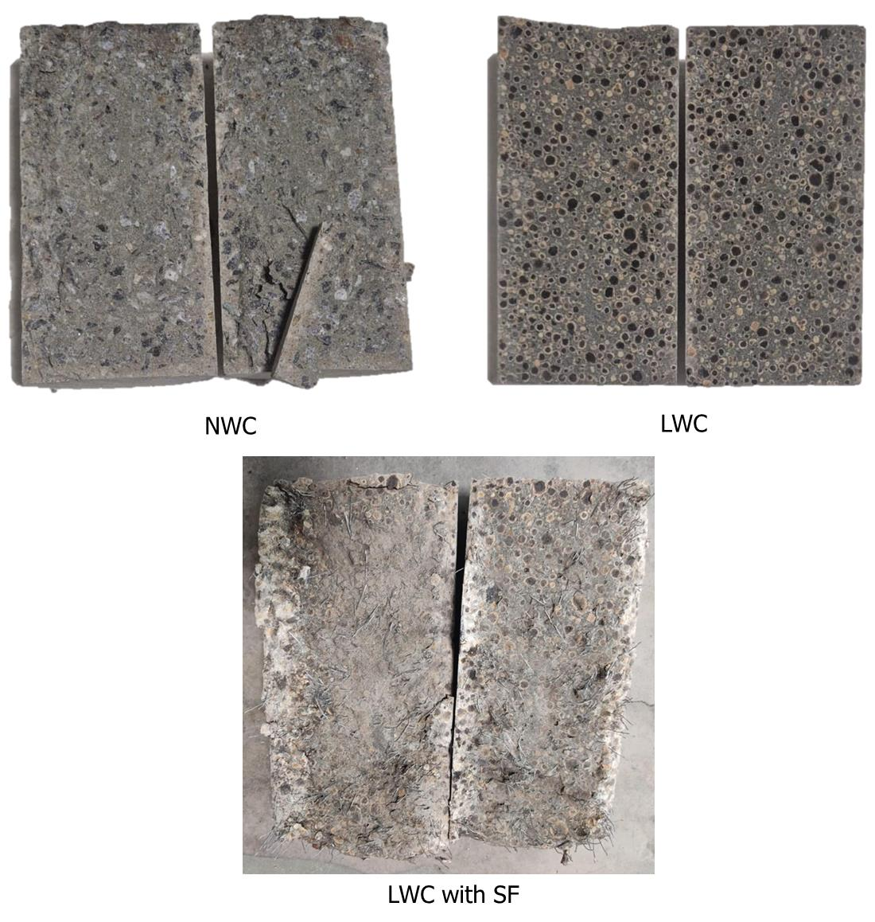
Figure 10. Failure Pattern under Splitting Tensile Load

  - Impact Resistance of Concrete Beams
    - Energy Absorption in Concrete Prisms
Impact resistance test findings are shown in Table 8. It lists the number of impacts required to cause the first crack (N₁), the number required for complete failure (N₂), the difference between N₂ and N₁, and the energy absorbed at the first impact (E₁) and cumulative energy absorbed before failure (E₂). Adding SF made LWC much better at withstanding impacts, with more fibres yielding further improvement.
Table 8: Impact Energy Absorption of Concrete Prisms
Mix ID | N₁ | N₂ | N₂$-$N₁ | E₁(N-m) | E₂(N-m)
NWC | 2 | 4 | 2 | 26.49 | 52.97
LWC00 | 1 | 2 | 1 | 13.24 | 26.49
LWC05 | 5 | 20 | 15 | 66.22 | 264.87
LWC10 | 15 | 45 | 30 | 198.65 | 595.96
LWC15 | 35 | 221 | 186 | 463.52 | 2927.81
NWC took two impacts to crack and four to fail, with impact energies of 26.49 and 52.97 N-m. In comparison, LWC00 was the least resistant, cracking after one impact and failing after two, with energies of 13.24 and 26.49 N-m, respectively. LWC00’s lower resistance stems from its more porous property and weaker bond between SFA and cement, which makes cracks start and spread more easily under repeated impacts.
The addition of SF caused substantial improvements in impact resistance. Specifically, the number of impacts to first crack increased markedly from one in LWC00 to 5, 15, and 35 in LWC05, LWC10, and LWC15, respectively, which is striking. The corresponding first-crack impact energies (E₁) increased from 13.24 N-m to 66.22, 198.65, and 463.52 N-m. Similarly, the number of impacts to failure rose from two in LWC00 to 20, 45, and 221 in LWC05, LWC10, and LWC15, with associated failure impact energies (E₂) of 264.87, 595.96, and 2927.81 N-m, respectively. Furthermore, post-cracking impact resistance (N₂ – N₁), as shown in Table 8, increased from 1 in LWC00 to 15, 30, and 186 in LWC05, LWC10, and LWC15, respectively. Relative to LWC00, the failure resistance increased by approximately 900%, 2150%, and 10,950% for LWC05, LWC10, and LWC15, respectively.
While LWC05 performed better than LWC00, the improvement was notably less than that observed for LWC10 and LWC15. This outcome is attributed to the relatively low fibre dosage in LWC05. As a result, fewer fibres are available to bridge and arrest cracks. Consequently, the mechanisms governing stress redistribution and energy dissipation were less effective compared to mixtures with higher fibre contents.
The marked improvement in impact resistance is primarily attributed to the SF’s crack-bridging capability. These fibres facilitate stress transfer across propagating cracks, delay crack growth, and dissipate impact energy through debonding, friction, and pull-out. With increasing fibre content, the energy absorption capacity rose markedly. LWC15 absorbed up to 463.52 N-m at first crack and 2927.81 N-m at failure, underscoring its exceptional resistance to repeated impact loading.
A corresponding increase in post-cracking resistance (N₂ – N₁) was also observed as the fibre content increased. While LWC00 sustained only one additional impact after crack initiation, LWC15 resisted a further 186 impacts before failure. This indicates a substantial improvement in toughness and residual load-carrying capacity. The much greater increase in N₂ and E₂ compared with N₁ and E₁ suggests that steel fibres contribute more significantly to post-cracking toughness and energy absorption than to delaying initial crack formation.
The superior performance of LWC15 demonstrates that steel fibres can effectively transform lightweight concrete. They convert it from a brittle material into a highly ductile, energy-absorbing composite. These enhanced characteristics are particularly beneficial for structures subject to dynamic and impact loading. Examples include crash barriers, industrial floors, protective structures, and transportation infrastructure, where improved toughness and impact resistance are critical. Figure 11 shows the failed specimens after impact testing. It can be observed that NWC and LWC00 exhibit nearly straight cracks with minimal material loss at the crack faces. However, in the case of LWC05, several impacts were needed to completely fail the specimens, leading to multiple cracks, due to which more material loss was observed at the cracked face.
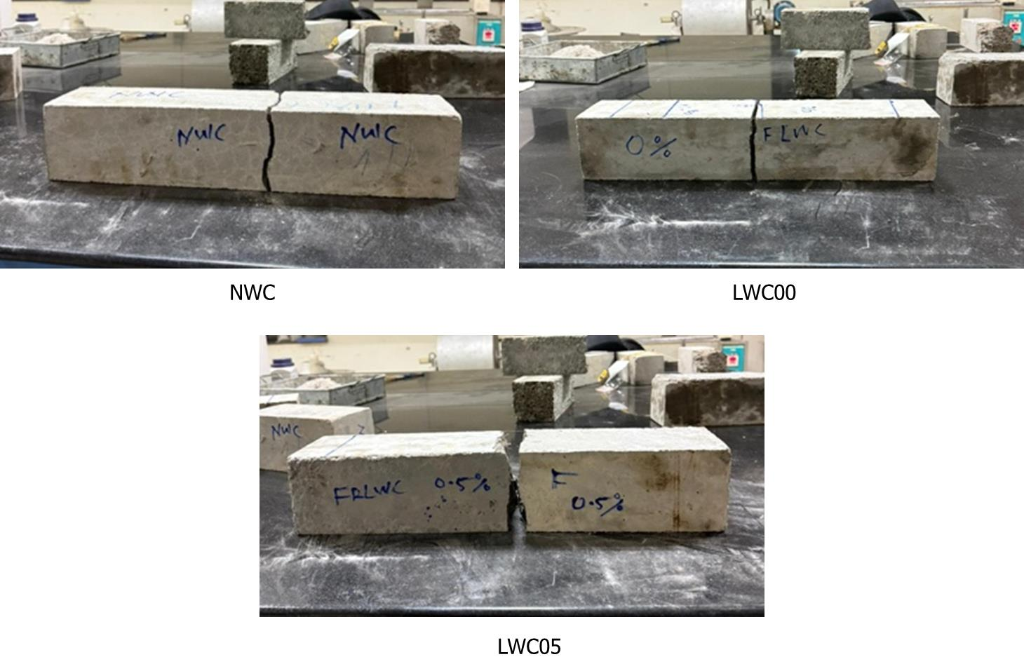
Figure 11. Failure of Beams when Subjected to Impact
    - Impact Response of Concrete Mixtures
The displacement of beams extracted from the acceleration data is shown in Table 9. The filtered acceleration and displacement histories for different concrete types are shown in Figures 11 to 15. The displacement results showed a clear variation in the impact response of the different concrete mixtures.
Table 9. Maximum Displacement of Beams after First Impact
Mix Id | Peak Displacement, mm | SD, mm
NWC | 0.28 | 0.005
LWC00 | 0.08 | 0.0163
LWC05 | 0.14 | 0.0144
LWC10 | 0.85 | 0.0173
LWC15 | 0.71 | 0.0686

NWC recorded a maximum displacement of 0.28 mm, reflecting a relatively stiff response under impact loading. In comparison, LWC00 exhibited a much lower displacement of 0.08 mm, indicating a brittle response characterised by rapid crack propagation and limited deformation capacity.
With the inclusion of steel fibres, the displacement increased significantly. LWC05 (0.5% fibre) exhibited a displacement of 0.14 mm, representing an increase of approximately 75% compared to LWC00. When the fibre content was increased to 1.0% in LWC10, the displacement rose sharply to 0.85 mm, corresponding to approximately 963% relative to LWC00 and about 204% relative to NWC. This substantial increase indicates a significant improvement in deformation capacity due to fibre reinforcement.
The enhanced deformation behaviour is primarily attributed to the crack-bridging action of steel fibres, which delays crack propagation and promotes gradual failure. During impact loading, fibres undergo progressive debonding and pull-out, absorbing energy through deformation and improving the ductility of the concrete.
When the fibre content was further increased to 1.5% in LWC15, the displacement decreased slightly to 0.71 mm, representing a reduction of approximately 16% compared to LWC10. This reduction can be attributed to the increased matrix stiffness at higher fibre content, which limits peak deformation. As reported, the modulus of elasticity also increases with the addition of steel fibres (Gul et al., 2014), further enhancing the stiffness of the concrete matrix. However, LWC15 still exhibited a significantly higher displacement than NWC, with an increase of approximately 154%, indicating improved deformation capacity under impact loading.
From an energy perspective, LWC-SF benefits from a combined energy dissipation mechanism involving both aggregate crushing and fibre-induced deformation. The porous structure of SFA contributes to internal energy absorption, while fibres enhance energy dissipation through crack bridging, pull-out, and controlled deformation. This combined effect results in improved impact performance and higher damping than in normal-weight concrete.
According to the work-energy principle, increased deformation leads to greater energy absorption, thereby reducing the impact force. Similarly, based on the impulse-momentum relationship, a reduction in peak force increases impact duration. These characteristics are highly desirable in crash barrier applications, as they reduce the force and deceleration transmitted to vehicles and occupants.
Overall, the results demonstrate that LWC-SF exhibits significantly improved deformation capacity and energy dissipation compared to both NWC and LWC, making it suitable for applications requiring controlled impact response.
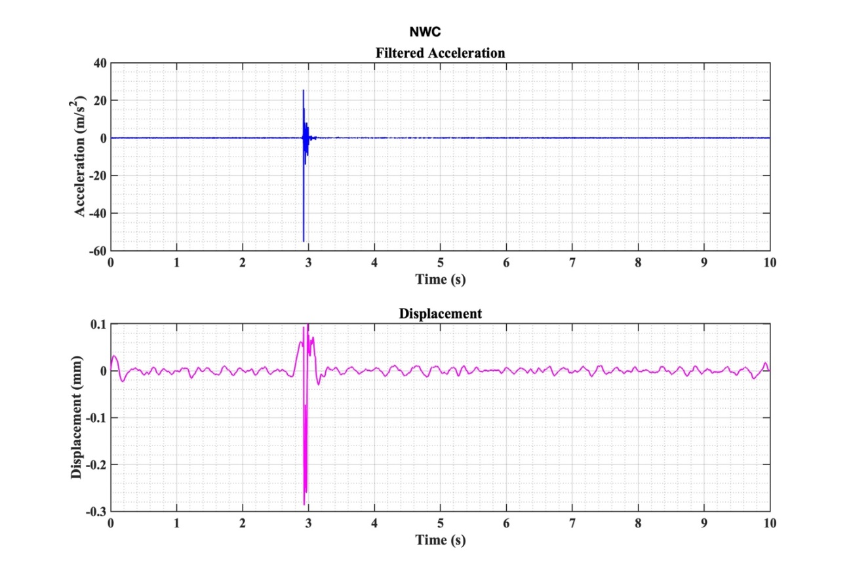
Figure 11: Filtered Acceleration and displacement time histories of NWC under impact loading
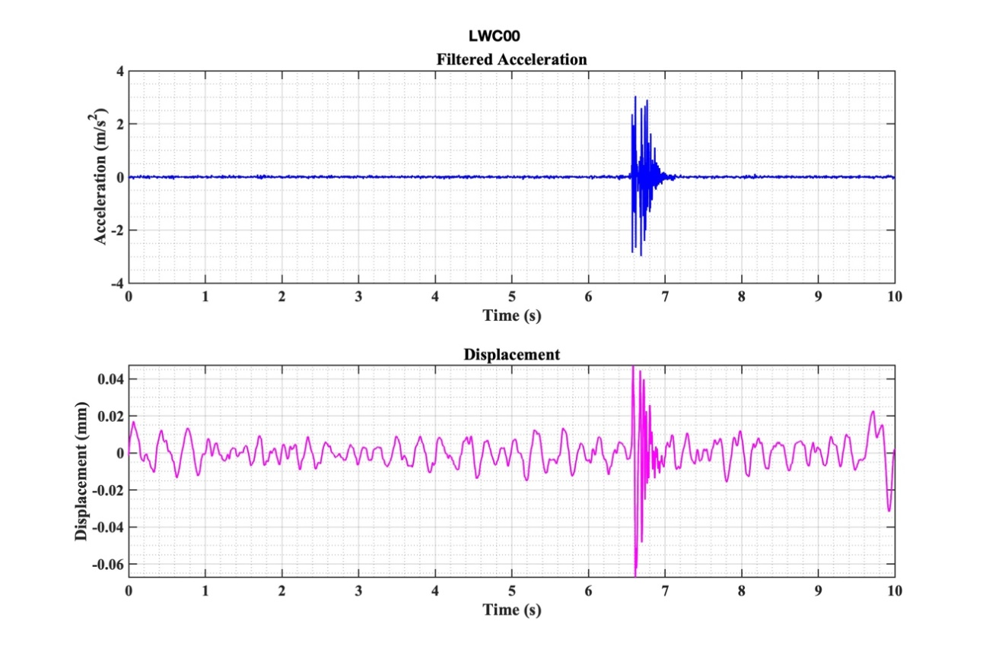
Figure 12: Filtered Acceleration and displacement time histories of LWC00 under impact loading

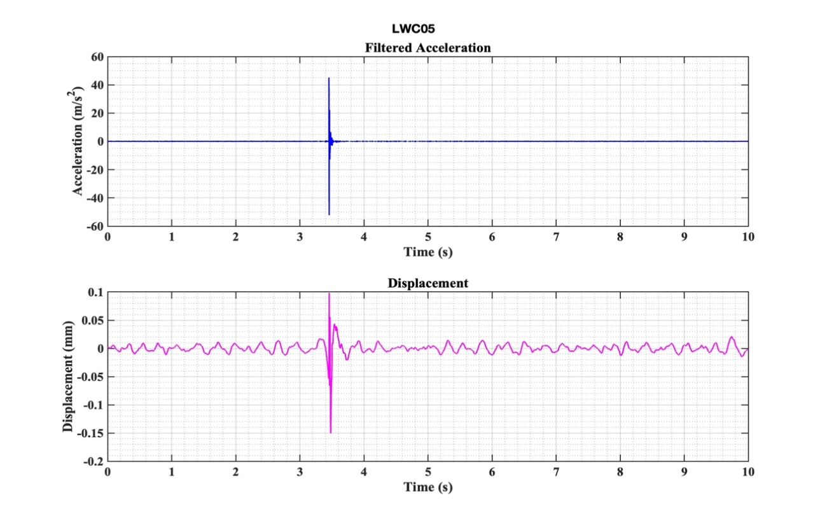
Figure 13: Filtered Acceleration and displacement time histories of LWC05 under impact loading
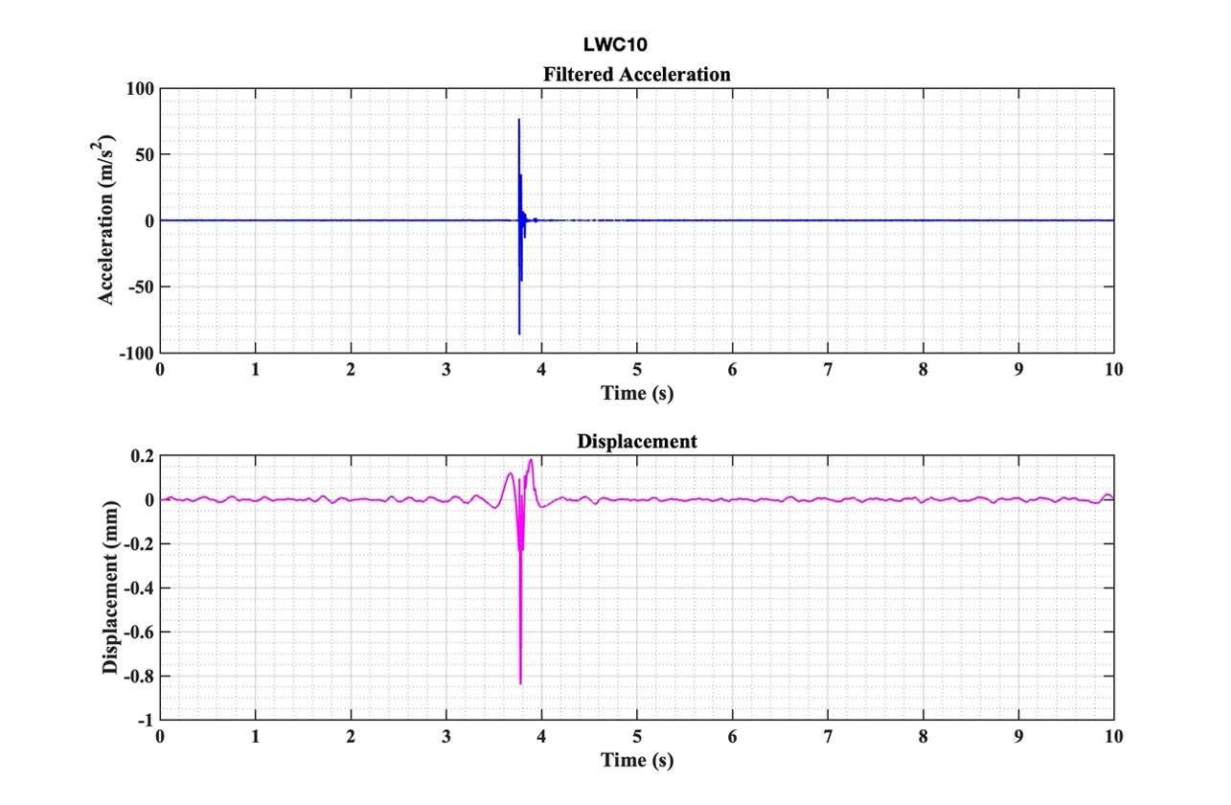
Figure 14: Filtered Acceleration and displacement time histories of LWC10 under impact loading
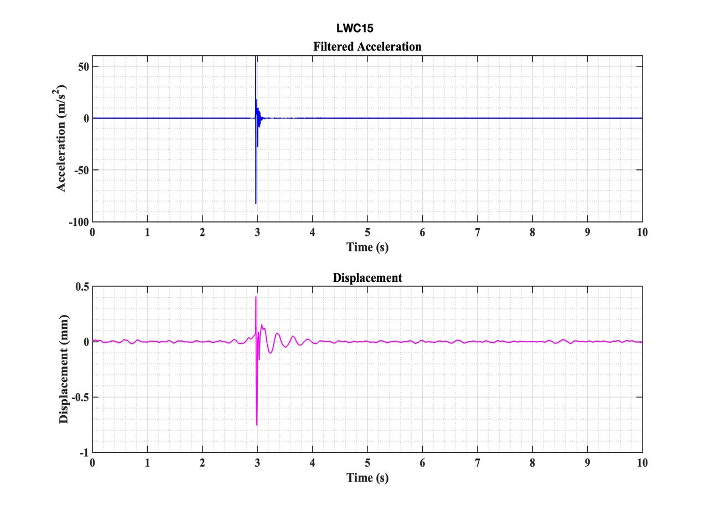
Figure 15: Filtered Acceleration and displacement time histories of LWC15 under impact loading

    - Cost and Energy Efficiency Analysis
Eco-engineered quantification of different mixtures is shown in Table 10, where the cost and energy absorption characteristics were quantified as a single parameter.
Table 10: Cost and Energy Efficiency of Concrete Mixtures
Mix ID | Cost (Rs/m³) | Energy (N-m) | Cost/Energy (Rs/N-m)
NWC | 4,945.24 | 52.97 | 93.36
LWC00 | 4,411.62 | 26.49 | 166.54
LWC05 | 8,336.62 | 264.87 | 31.47
LWC10 | 12,261.62 | 595.96 | 20.57
LWC15 | 16191.62 | 2927.81 | 5.53

NWC had a cost of 4945.24 Rs/m³ and absorbed 52.97 N-m of impact energy, resulting in a cost-to-energy ratio of 93.36 Rs/N-m. LWC00 had a lower cost of 4411.62 Rs/m³, which is about 10.8% lower than NWC. However, LWC00 absorbed only 26.49 N-m of energy, giving the highest cost-to-energy ratio of 166.54 Rs/N-m. This indicates that although LWC00 is cheaper, its impact energy absorption efficiency is low.
The inclusion of steel fibres increased the cost of the lightweight concrete mixtures due to their relatively high cost. Compared to LWC00, the cost increased by approximately 89% for LWC05, 177.9% for LWC10, and 267.0% for LWC15. However, this increase in cost was accompanied by a substantial improvement in impact energy absorption.
The cost-to-energy ratio decreased significantly as fibre content increased. Compared to LWC00, the cost-to-energy ratio reduced by approximately 81.1% for LWC05, 87.6% for LWC10, and 96.7% for LWC15. Similarly, compared to NWC, the cost-to-energy ratio reduced by about 66.3%, 78%, and 94.1% for LWC05, LWC10, and LWC15, respectively. This shows that LWC-SF provides much greater impact energy absorption per unit cost.
Among all mixtures, LWC15 exhibited the lowest cost-to-energy ratio of 5.53 Rs/N-m, despite having the highest cost per cubic metre. This indicates that higher fibre content greatly improves the economic efficiency of the concrete in terms of energy absorption. Therefore, for crash barrier applications where impact energy dissipation is critical, fibre-reinforced lightweight concrete is more cost-effective than both normal-weight concrete and plain lightweight concrete when performance is evaluated in terms of energy absorption capacity.
Based on the above laboratory studies, LWC15 was selected to fabricate a 1:3 scaled model of the New Jersey Crash Barrier. Although LWC15’s initial cost is high, its cost-to-energy ratio is significantly low, which means the agency needs to spend less to ensure high-energy absorbance compared to other mixtures.

  - Impact Testing of Crash Barriers
The impact performance of the crash barrier specimens was evaluated using the number of blows required to initiate the first visible crack (N₁) and the number of blows corresponding to ultimate failure or the termination of testing (N₂), together with the associated impact energies (E₁ and E₂), as presented in Table 11. NWC barrier developed its first crack after 4 blows and failed after 10 blows, corresponding to impact energy of 549.2 N·m and 1373 N·m, respectively. In contrast, the LWC15 crash barrier exhibited significantly higher impact resistance, with first cracking occurring after 7 blows and the specimen remaining intact up to the maximum test limit of 20 blows, corresponding to impact energies of 961.1 N·m and 2746 N·m, respectively. Compared with NWC, LWC15 showed an increase of approximately 75% in the number of blows required for first crack and a 100% increase in the number of blows sustained before the termination of testing. Similar improvements were observed in the corresponding impact energies, with increases of about 75% and 100% at the first-cracking and final-loading stages, respectively. The NWC barrier exhibited severe localised damage and brittle failure at the 10th impact, characterised by extensive cracking, spalling, and material disintegration. Conversely, the LWC15 barrier exhibited only localised surface damage even after 20 impacts, indicating a more controlled failure mechanism. In LWC, the porous lightweight aggregate acts as the weaker phase and undergoes progressive crushing rather than sudden fracture, thereby dissipating a considerable amount of impact energy. Furthermore, the presence of steel fibres enhances impact resistance through crack-bridging action, delaying crack propagation, limiting crack opening, and preventing sudden brittle failure, thereby improving ductility and post-cracking behaviour.
Figure 16 shows the failure pattern of NWC and LWC15 from different views. On the front face, the NWC specimen exhibited highly localised crushing and spalling around the impact zone, with cracks propagating rapidly toward the upper surface, resulting in abrupt material disintegration. In contrast, the LWC15 specimen demonstrated a more distributed and controlled failure pattern, characterised by progressive surface crushing, reduced spalling, and stable crack propagation over a wider area while maintaining overall structural integrity. On the rear face, the NWC specimen developed a wide, continuous vertical crack after only 10 impacts, extending through the depth of the specimen and widening toward the bottom, indicating severe tensile failure and rapid crack growth. Conversely, the LWC15 specimen developed a similar crack only after 20 impacts; however, the crack remained narrower, more uniform, and less open throughout its depth, reflecting a more controlled failure process. On the top surface, the NWC specimen exhibited a wide, irregular through-thickness crack with multiple closely spaced crack lines and branching, indicating unstable crack growth and brittle splitting. By comparison, the LWC15 specimen developed a single, narrower, and more uniform crack extending from the rear face to the top surface. Localised crushing near the impact region was observed due to the progressive crushing of sintered fly ash aggregates, demonstrating controlled crack development and enhanced energy dissipation.
In addition, the NWC specimen produced highly localised fragmentation, consisting of large angular fragments and broken coarse aggregates, concentrated near the impact zone, reflecting sudden brittle failure. Such larger fragments may be projected outward during impact, can be high-velocity as secondary hazards, posing risks to nearby road users and infrastructure. Conversely, the LWC15 specimen exhibited finer, more uniformly distributed debris despite sustaining twice as many impacts. The smaller fragment size and wider distribution indicate gradual material degradation and effective dissipation of impact energy. This improved fragmentation behaviour is attributed to the combined effects of steel fibres and lightweight aggregates, in which fibre bridging and pull-out mechanisms restrict the formation of large fragments while the crushing of porous lightweight aggregates contributes additional energy absorption.
Table 11: Impact Performance of Crash Barrier Specimens
Mix ID | N₁ | N₂ | E₁ (N-m) | E₂ (N-m)
NWC | 4 | 10 | 549.2 | 1373
LWC15 | 7 | 20 | 961.1 | 2746

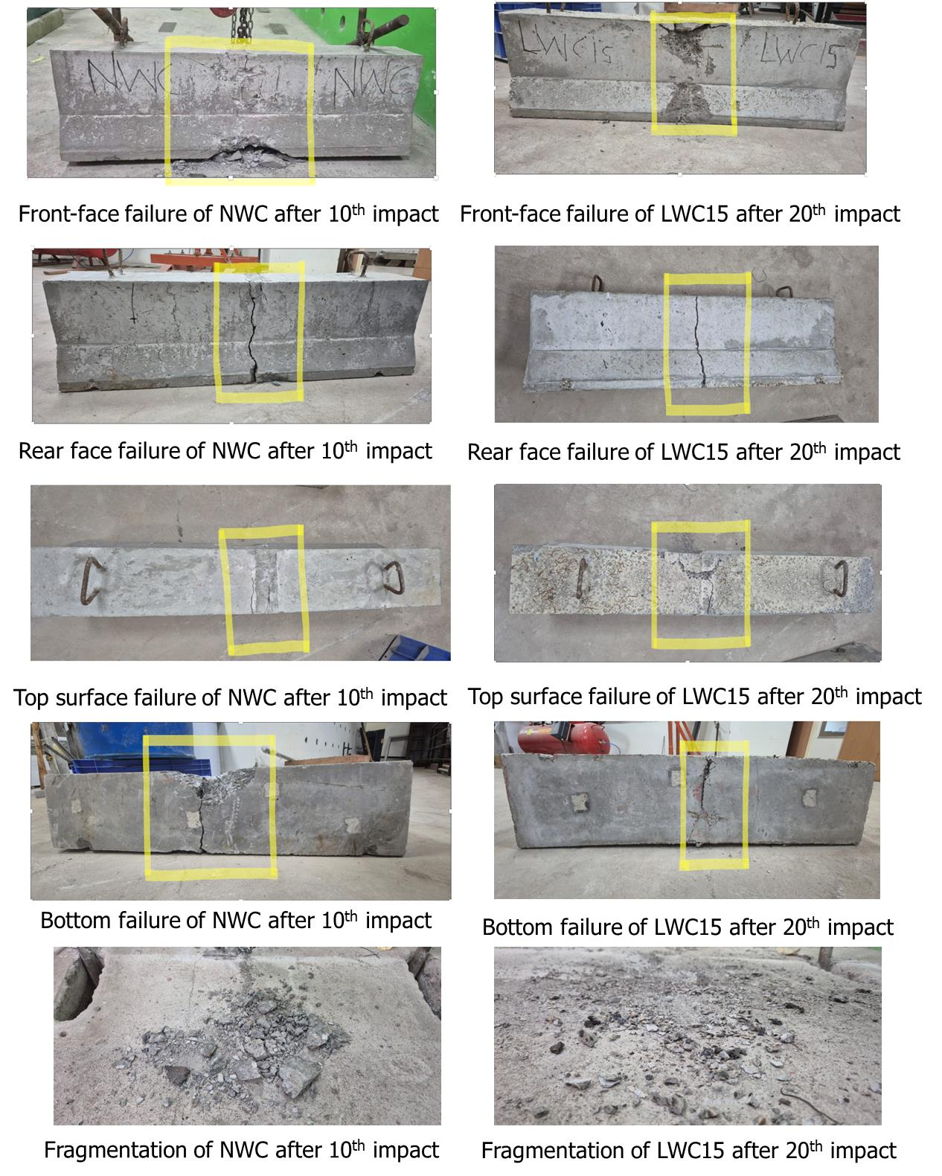
Figure 16. Failure of 1:3 Scaled New Jersey Crash Barrier

  - Impact Response of Crash Barrier Specimens

The deformation behaviour of crash barrier specimens under impact loading was assessed to determine their ductility and energy absorption characteristics. Figures 17 and 18 shows the acceleration and displacement histories of different crash barriers. As summarised in Table 12, a pronounced difference emerged between the NWC and LWC15 specimens. NWC exhibited a maximum deformation of 4.22 mm, reflecting a relatively stiff response with limited ability to accommodate impact-induced strains. This limited ductility is typical of conventional concrete, which tends to dissipate energy through rapid crack initiation and propagation, resulting in a brittle failure mode. In contrast, LWC15 recorded a maximum deformation of 12.70 mm, representing a 201% increase compared with NWC.
A similar trend was observed in the prism impact tests, where LWC15 exhibited deformation values approximately 154% higher than those of NWC. The consistency of this behaviour across different specimen configurations confirms the effectiveness of steel fibre reinforcement in improving the deformation capacity and energy absorption performance of lightweight concrete. From a structural standpoint, increased deformation is advantageous for crash barrier applications because it allows a greater proportion of the impact energy to be dissipated through controlled deformation.
Overall, the results demonstrate that LWC with SF possesses substantially greater deformation capacity and impact energy dissipation potential than NWC. The superior ductile behaviour exhibited by LWC15 highlights its suitability for crash barrier systems, where controlled deformation and efficient energy absorption are critical performance requirements.
Table 12: Maximum Deformation of Crash Barrier Specimens
Mix ID | Deformation (mm)
NWC | 4.22
LWC15 | 12.70

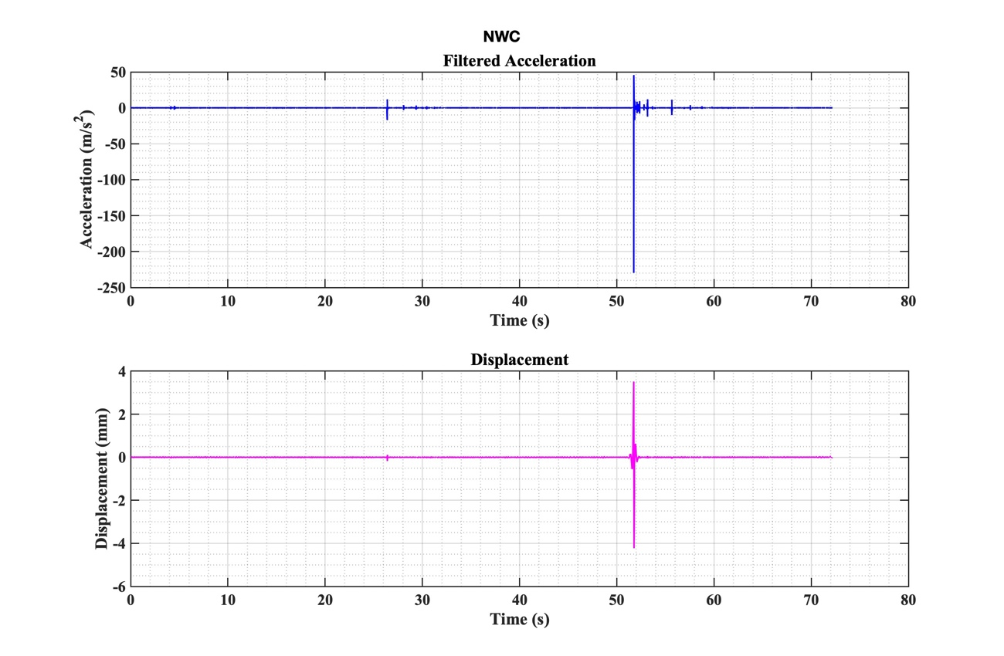

Figure 17: Filtered Acceleration and displacement time histories of Crash barrier specimen under impact loading
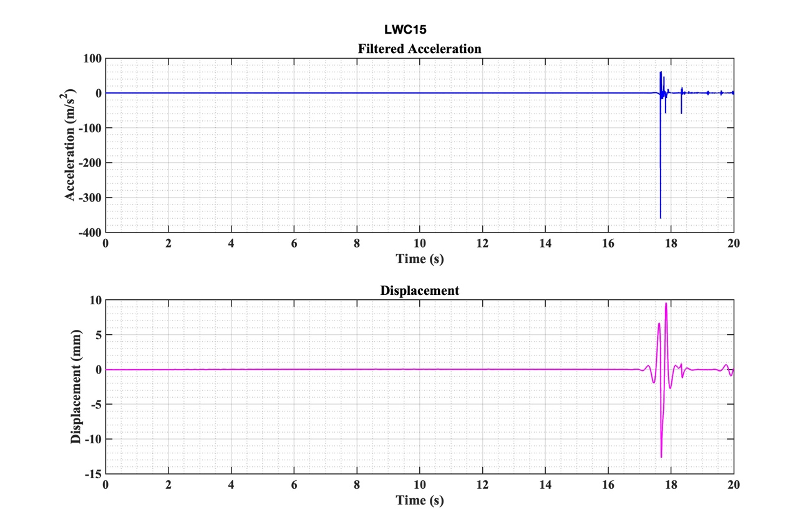
Figure 18: Filtered Acceleration and displacement time histories of Crash barrier specimen under impact loading

- CONCLUSION
The main objective of the study was to investigate the energy absorption characteristics of concrete made with lightweight aggregate and steel fibers for crash barrier applications.
  - The density of lightweight aggregate concrete was found to be significantly lower than that of conventional concrete. This characteristic eases the transportation and handling of precast elements such as crash barriers.
  - The study showed that incorporating lightweight aggregate concrete as a replacement for natural coarse aggregate produced compressive strength of more than 40 MPa, which is the recommended strength requirement for crash barrier applications.
  - The porous nature of lightweight aggregates increased the brittleness of the concrete significantly, decreasing its potential for energy-absorption characteristics, such as crash barriers.
  - The incorporation of steel fibers depicted significant improvements in energy absorption characteristics coupled with the crushing behaviour of lightweight aggregates, as observed from beam impact studies.
  - The cost-to-energy parameter introduced in this study was able to balance cost and energy absorption characteristics, thus recommending an engineered way of selecting a concrete mixture for crash barrier applications.
  - The 1:3 scaled model of the New Jersey crash barrier, when subjected to impact, depicted observations similar to those seen in the laboratory study, thus validating laboratory findings.
  - The crushing behaviour of SFA under impact resulted in the formation of finer, more evenly distributed fragments, thereby reducing the generation of large projectile-like debris and minimising secondary hazards to road users. In addition, the utilisation of SFA, produced from fly ash, supports waste utilisation and sustainability goals, particularly in India, where a significant portion of fly ash remains unutilised.

Recommendations: The developed lightweight steel fibre-reinforced concrete mixture is highly suitable for crash barrier applications, particularly for highway medians, bridge barriers, and roadside safety systems. The LWC15 mixture meets the strength requirements of different specifications, such as IRC:6-2016, IRC:119-2015, JTG D81-2017, and provides an enhanced energy-absorbing and ductile alternative to conventional normal-weight concrete barriers.
The material enhances occupant safety by reducing peak impact forces through increased deformation capacity and efficient energy dissipation. Furthermore, the improved fragmentation behaviour, characterised by finer and less hazardous debris, minimises the risk of secondary damage to road users and nearby infrastructure.
In addition, the incorporation of industrial by-products such as fly ash, GGBS, and sintered fly ash aggregates contributes to sustainability by reducing dependence on natural resources, lowering environmental impact, and promoting the utilisation of waste. This aligns well with global infrastructure development goals and circular economy initiatives.

Future Scope: To investigate the behaviour of lightweight fibre-reinforced concrete crash barriers under full-scale dynamic vehicle impact loading in accordance with IRC:119-2015 and international standards such as EN 1317. The study should include evaluation of occupant risk parameters, particularly the Acceleration Severity Index (ASI), to assess safety performance.
To develop advanced numerical models using software such as LS-DYNA or ABAQUS to simulate vehicle–barrier interactions. These models can be used to predict impact response under different containment levels and to evaluate vehicle deformation and passenger safety using parameters such as ASI.

References

- Abid, S.R., Abdul-Hussein, M.L., Ayoob, N.S., Ali, S.H. and Kadhum, A.L., 2020. Repeated drop-weight impact tests on self-compacting concrete reinforced with microsteel fiber. Heliyon, 6(1), e03198. Available at: https://doi.org/10.1016/j.heliyon.2020.e03198
- Ahmed, M.A. and Dutta, S., 2025. Acoustic emission entropy as an indicator of damage at fiber–matrix interface in UHPC during fiber pull-out. Journal of Building Engineering, 114, p.114345. Available at: https://doi.org/10.1016/j.jobe.2025.114345
- American Association of State Highway and Transportation Officials (AASHTO), 2011. Roadside Design Guide. Washington, DC: AASHTO.
- ACI 211.2 (1998). Standard Practice for Selecting Proportions for Structural Lightweight Concrete. American Concrete Institute (ACI), Farmington Hills, Michigan, USA.
- American Concrete Institute (ACI), 1999. ACI 544.2R-89: Measurement of Properties of Fiber Reinforced Concrete. Farmington Hills, MI: American Concrete Institute.
- Association for Safe International Road Travel (ASIRT), 2026. Road Safety Facts. Available at: https://www.asirt.org/facts/ (Accessed: 26 March 2026).
- Bureau of Indian Standards (BIS), 1963. IS 2386 (Part III): 1963 Methods of Test for Aggregates for Concrete, Part III: Specific Gravity, Density, Voids, Absorption and Bulking. New Delhi: Bureau of Indian Standards.
- Bureau of Indian Standards (BIS), 1963. IS 2386 (Part IV): 1963 Methods of Test for Aggregates for Concrete, Part IV: Mechanical Properties. New Delhi: Bureau of Indian Standards.
- Bureau of Indian Standards (BIS), 1970. IS 383:1970 Specification for Coarse and Fine Aggregates from Natural Sources for Concrete (Second Revision). New Delhi: Bureau of Indian Standards.
- Bureau of Indian Standards (BIS), 1987. IS 12269: Indian Standard Specification for 53 Grade Ordinary Portland Cement. New Delhi: Bureau of Indian Standards.
- Bureau of Indian Standards (BIS), 2000. IS 456:2000 Plain and Reinforced Concrete—Code of Practice (Fourth Revision). New Delhi: Bureau of Indian Standards.
- Bureau of Indian Standards (BIS), 2013. IS 12269:2013 Ordinary Portland Cement, 53 Grade—Specification (First Revision). New Delhi: Bureau of Indian Standards.
- Bureau of Indian Standards (BIS), 2018. IS 9142 (Part 2): 2018 Artificial Lightweight Aggregates for Concrete Masonry Units and Structural Concrete, Part 2: Sintered Fly Ash Aggregate—Specification. New Delhi: Bureau of Indian Standards.
- Bureau of Indian Standards (BIS), 2019. IS 10262:2019 Concrete Mix Proportioning—Guidelines (Second Revision). New Delhi: Bureau of Indian Standards.
- Chen, H.-J., Huang, C.-H. and Tang, C.-W., 2010. Dynamic properties of lightweight concrete beams made by sedimentary lightweight aggregate. Journal of Materials in Civil Engineering, 22(6), pp.599–606. Available at: https://doi.org/10.1061/(ASCE)MT.1943-5533.0000061
- Elango, K.S., Sanfeer, J., Gopi, R., Shalini, A., Saravanakumar, R. and Prabhu, L., 2021. Properties of lightweight concrete – A state of the art review. Materials Today: Proceedings, 46, pp.4059–4062. Available at: https://doi.org/10.1016/j.matpr.2021.02.571
- Gao, J., Suqa, W. and Morino, K., 1997. Mechanical properties of steel fiber-reinforced high-strength lightweight concrete. Cement and Concrete Composites, 19(4), pp.307–313. Available at: https://doi.org/10.1016/S0958-9465(97)00023-1
- Gul, M., Bashir, A. and Naqash, J.A., 2014. Study of Modulus of Elasticity of Steel Fiber Reinforced Concrete. International Journal of Engineering and Advanced Technology (IJEAT), 3(4), pp.304–309. Available at: https://www.ijeat.org/portfolio-item/d2995043414
- Hou, S., Zheng, Y., Xie, J. and Han, X., 2014. Optimization design of NJ shaped guardrail based on collision safety consideration. International Journal of Computational Methods, 11(6), 1350083. Available at: https://doi.org/10.1142/S0219876213500837
- IRC:119-2015 Guidelines for Traffic Safety Barriers. Indian Roads Congress, New Delhi
- IRC:6 (2016). Standard Specifications and Code of Practice for Road Bridges. Indian Roads Congress, New Delhi.
- IRC:SP:84 (2014). Manual of Specifications and Standards for Four Laning of Highways Through Public Private Partnership, Indian Roads Congress, New Delhi
- IS 10262 (2019). Concrete mix proportioning guidelines, Bureau of Indian Standards, New Delhi.
- JTG D81 (2017). Design Specification for Highway Safety Facilities, Highway & Transportation Industry Standard, Ministry of Transport, Republic of China
- Kim, W., Lee, I., Kim, K., Jeong, Y. and Lee, J., 2019. Evaluation of concrete barriers with novel shock absorbers subjected to impact loading. Archives of Civil and Mechanical Engineering, 19, pp.657–671. Available at: https://doi.org/10.1016/j.acme.2019.01.004
- Li, N., Park, B.B. and Lambert, J.H., 2018. Effect of guardrail on reducing fatal and severe injuries on freeways: Real-world crash data analysis and performance assessment. Journal of Transportation Safety & Security, 10(5), pp.455–470. Available at: https://doi.org/10.1080/19439962.2017.1297970
- Li, N., Zhang, S., Long, G., Jin, Z., Yu, Y., Zhang, X., Xiong, C. and Li, H., 2021. Dynamic characteristics of lightweight aggregate self-compacting concrete by impact resonance method. Advances in Civil Engineering, 2021, Article ID 8811303. Available at: https://doi.org/10.1155/2021/8811303
- Mai, V.C., Vu, Q.A., Nguyen, V.T. and Pham, D.T., 2025. Performance assessment of UHPC composite barriers under velocity impacts. Case Studies in Construction Materials, 23, e05062. Available at: https://doi.org/10.1016/j.cscm.2025.e05062
- Mehrara M. A., Rezapour, M. and Ksaibati, K., 2020. Investigating the relationship between crash severity, traffic barrier type, and vehicle type in crashes involving traffic barrier. Journal of Traffic and Transportation Engineering (English Edition), 7(1), pp.125–136. Available at: https://doi.org/10.1016/j.jtte.2019.03.004
- Ministry of Road Transport and Highways, 2022. Road Accidents in India—2021. Press Information Bureau. Available at: https://www.pib.gov.in/PressReleasePage.aspx?PRID=1887097 (Accessed: 30 March 2026).
- Mohammed, H.J. and Zain, M.F.M., 2016. Experimental application of EPS concrete in the new prototype design of the concrete barrier. Construction and Building Materials, 124, pp.312–342. Available at: https://doi.org/10.1016/j.conbuildmat.2016.07.105
- Mohammadi, Y., Carkon-Azad, R., Singh, S.P. and Kaushik, S.K., 2009. Impact resistance of steel fibrous concrete containing fibres of mixed aspect ratio. Construction and Building Materials, 23, pp.183–189. Available at: https://doi.org/10.1016/j.conbuildmat.2008.01.002
- Nadesan, M.S. and Dinakar, P., 2017. Mix design and properties of fly ash waste lightweight aggregates in structural lightweight concrete. Case Studies in Construction Materials, 7, pp.336–347. Available at: https://doi.org/10.1016/j.cscm.2017.09.005
- Pan, L., Hao, H., Cui, J. and Pham, T.M., 2023. Numerical study on impact resistance of rubberised concrete roadside barrier. Advances in Structural Engineering, 26(1), pp.17–35. Available at: https://doi.org/10.1177/13694332221120130
- Raj, A., Nagarajan, P. and Pallikkara, S.A., 2020. Application of fiber-reinforced rubcrete for crash barriers. Journal of Materials in Civil Engineering, 32(12), p.04020358. Available at: https://doi.org/10.1061/(ASCE)MT.1943-5533.0003454
- Sahoo, S., Selvaraju, A.K. and Suriya Prakash, S., 2020. Mechanical characterization of structural lightweight aggregate concrete made with sintered fly ash aggregates and synthetic fibres. Cement and Concrete Composites, 113, 103712. Available at: https://doi.org/10.1016/j.cemconcomp.2020.103712
- Saxena, R., Siddique, S., Gupta, T., Sharma, R.K. and Chaudhary, S., 2018. Impact resistance and energy absorption capacity of concrete containing plastic waste. Construction and Building Materials, 176, pp.415–421. Available at: https://doi.org/10.1016/j.conbuildmat.2018.05.019
- Shen, W., Zhang, C., Yang, Z., Cao, L., Yang, Z. and Tian, B., 2014. Investigation on the safety concrete for highway crash barrier. Construction and Building Materials, 70, pp.394–398. Available at: https://doi.org/10.1016/j.conbuildmat.2014.07.060
- Singh, B., Singh, S.B. and Barai, S.V., 2023. Performance of concrete made using sintered fly ash lightweight aggregate – A review. The Indian Concrete Journal, 97(7), pp.41–59.
- Somani, P., Gaur, A. and Dhemla, P., 2025. Impact of Sintered Fly Ash Aggregate on Mechanical, Durability, and Thermal Performance of Concrete. Journal of Structural Design and Construction Practice (ASCE). Available at: https://doi.org/10.1061/JSDCCC.SCENG-1613
- Tambe, P., Tiwari, G., Andraskar, N. and Jain, U., 2024. Investigating crashworthiness of W-Beam guardrail crash barriers. International Journal of Crashworthiness, 29(3), pp.445–453. Available at: https://doi.org/10.1080/13588265.2023.2258628
- Tian, Y., Shi, S., Jia, K. and Hu, S., 2015. Mechanical and dynamic properties of high strength concrete modified with lightweight aggregates presaturated polymer emulsion. Construction and Building Materials, 93, pp.1151–1156. Available at: https://doi.org/10.1016/j.conbuildmat.2015.05.015
- NHTSA (2012). National Highway Traffic Safety Administration (NHTSA), 2012. Traffic Safety Facts 2010 Data, U.S. Department of Transportation ,Available at: https://crashstats.nhtsa.dot.gov/Api/Public/ViewPublication/811630
- Wang, H.T. and Wang, L.C., 2013. Experimental study on static and dynamic mechanical properties of steel fiber reinforced lightweight aggregate concrete. Construction and Building Materials, 38, pp.1146–1151. Available at: https://doi.org/10.1016/j.conbuildmat.2012.09.016
- World Health Organization, 2023. Global Status Report on Road Safety 2023. Available at: https://www.who.int/publications/i/item/9789240086517 (Accessed: 25 March 2026).
- Xue, W., Liao, Z., Liao, L., Hao, R. and Shen, L., 2025. Safety performance evaluation of ultra-high-performance concrete semi-assembled barrier. Applied Sciences, 15, p.3156. Available at: https://doi.org/10.3390/app15063156
- Yang, J., Xu, G., Cai, C.S. and Kareem, A., 2019. Crash performance evaluation of a new movable median guardrail on highways. Engineering Structures, 182, pp.459–472. Available at: https://doi.org/10.1016/j.engstruct.2018.12.090
- Yumrutas, H.I., Ozcanan, S., Apak, M.Y. and Anwer, M.J., 2023. Experimental and numerical comparative crashworthiness analysis of innovative renewable hybrid barrier with conventional roadside barriers. International Journal of Crashworthiness, 28(3), pp.334–350. Available at: https://doi.org/10.1080/13588265.2022.2075124
- Zain, M.F.B.M. and Mohammed, H.J., 2015. Concrete road barriers subjected to impact loads: An overview. Latin American Journal of Solids and Structures, 12, pp.1824–1858. Available at: https://doi.org/10.1590/1679-78251783
- Zhang, Q. and Baral, K., 2018. Development of High Performance Impact Resistant Concrete Mixtures for Crash Barrier Application. Final Report. Lafayette, LA: Department of Civil Engineering, University of Louisiana at Lafayette.

